
Land Information Ontario (LIO) Warehouse
Data Class Name: Wildlife Values Site
Documentation
Produced by: Spatial Data Support Unit
Ministry of Natural Resources and Forestry
Date: January 18, 2021

Purpose

This document provides additional information to support the use of geospatial data. The Physical Model Diagram provides a visual representation of the relationships in the data class. The Data Change History lists all the modelling and access changes that have occurred during the lifecycle of the data class. A data description identifying table and field names is available upon request.

Need Assistance?
Please contact LIO Support at lio@ontario.ca or 705-755-1878 if you require help.

Physical Model Diagram
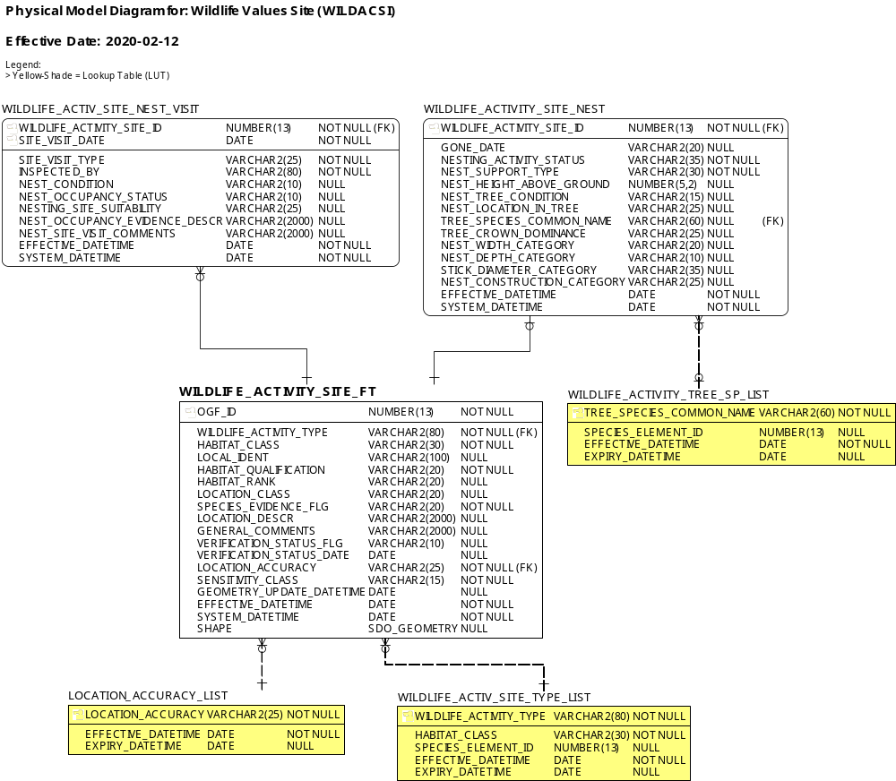
Data Class Change History
Data Class Name: Wildlife Values Site
Data Class Short Name: WILDACSI
Date  YYYY-MM-DD | Details of Change
2021-01-18 | Lookup table updates in WILDLIFE_ACTIV_SITE_TYPE_LIST. Apostrophes re-inserted into values (were removed during initial implementation due to LIO Editor bug when selecting subtypes). The following subtype names have been updated:  - Cooper’s Hawk Nesting Site
2021-01-12 | Lookup Table subtype updates: WILDLIFE_ACTIV_SITE_TYPE_LIST  - Oviposition spelling corrected for 3 subtypes  - Added missing subtype: Least Bittern Nesting Site
2020-02-12 | NEW data class created to consolidate and manage data from the following legacy NRVIS data classes:  - Den Site (DENSITE)  - Nesting Site (NESTING) non-colony bird species only*  * colony bird species nesting sites are stored in the Wildlife Values AREA (WILDACAR) layer.
Data Description
Please refer to the metadata record for the data description.

